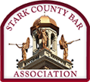
Stark County Bar Association Presents:

“BACK TO THE BASICS” LUNCHEON SERIES
LIVE INTERACTIVE WEBINAR
NEW LAWYER TRAINING & GENERAL CLE

WEDNESDAY, FEBRUARY 16, 2022

12:00-1:00 P.M.

February 16, 2022 Guardian Ad Litem

Attorney Allyson Blake will give a presentation on the Guardian Ad Litem Program.

