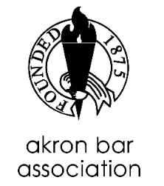
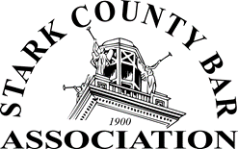
The 26th Annual White-Williams Bankruptcy Institute
April 1, 2022 8:20 a.m. – 4:40 p.m. The Hartville Kitchen
Live Seminar
6.25 CLEs applied for (5.25 general hrs. & 1 professional conduct hr.)
7:45 am – 8:20 am Registration

8:20 am – 8:30 am Welcome
Michelle Limas-Jackson, Esq., Chair, Bankruptcy Committee, Stark County Bar Association
Joseph A. Ferrise, Esq., Chair, Bankruptcy & Commercial Law Section, Akron Bar Association

8:30 am – 9:00 am U.S. Trustee Update
Kate Bradley, Esq. and John Weaver, Esq., U.S. Trustees

9:00 am – 10:00 am Case Law Update
Hon. John P. Gustafson, US Bankruptcy Court, Northern District of Ohio
10:00 am – 10:15 am Break
10:15 am – 11:15 am The Intersection Between Domestic Relations and Bankruptcy
Keith L. Rucinski, Esq., Akron Chapter 13 Trustee; Harold A. Corzin, Esq., Akron Chapter 7 Trustee;
Matthew P. Kreitzer, Chief Magistrate of Stark County Court of Common Pleas, Domestic Relations Division; Deborah C. Watkins, Esq., Summit County Prosecutor’s Office

11:15 am – 12:00 noon Estate Planning and Bankruptcy
D. Bowen Loeffler, Esq., The Loeffler Law Firm LLC; Anthony J. DeGirolamo, Esq., Canton Chapter 7 Trustee

12:00 noon – 12:15 pm Break – Please leave meeting room for staff to prepare for lunch.

12:15 pm -1:15 pm Lunch
Presentation by George Vogl of Stretto

1:15 pm – 1:45 pm Debt Settlement Companies
Julie K. Zurn, Esq., Akron Chapter 7 Trustee; Teresa G. Santin, Esq., Brouse McDowell LPA
1:45 pm – 2:15 pm Cryptocurrency and NFTs
Ryan R. McNeil, Esq., McNeil Law Firm, LLC

2:15 pm – 2:45 pm Bankruptcy Analytics
Dynele L. Schinker-Kuharich, Esq., Canton Chapter 13 Trustee; Michael A. Steel, Esq., Steel &
Company Law Firm

2:45 pm – 3:00 pm Pie Break sponsored by Vance P. Truman, Esq.

3:00 pm – 3:30 pm Tax Claims
Alison L. Archer, Esq., Office of the Ohio Attorney General; Suzana K. Koch, Esq., Assistant U.S.
Attorney

3:30 pm – 4:30 pm Malpractice Claims in Bankruptcy
Gretchen J. Mote, Esq., OBLIC Director of Loss Prevention

4:30 pm – 4:40 pm Closing Remarks and Drawing for Dean Wyman Scholarship

